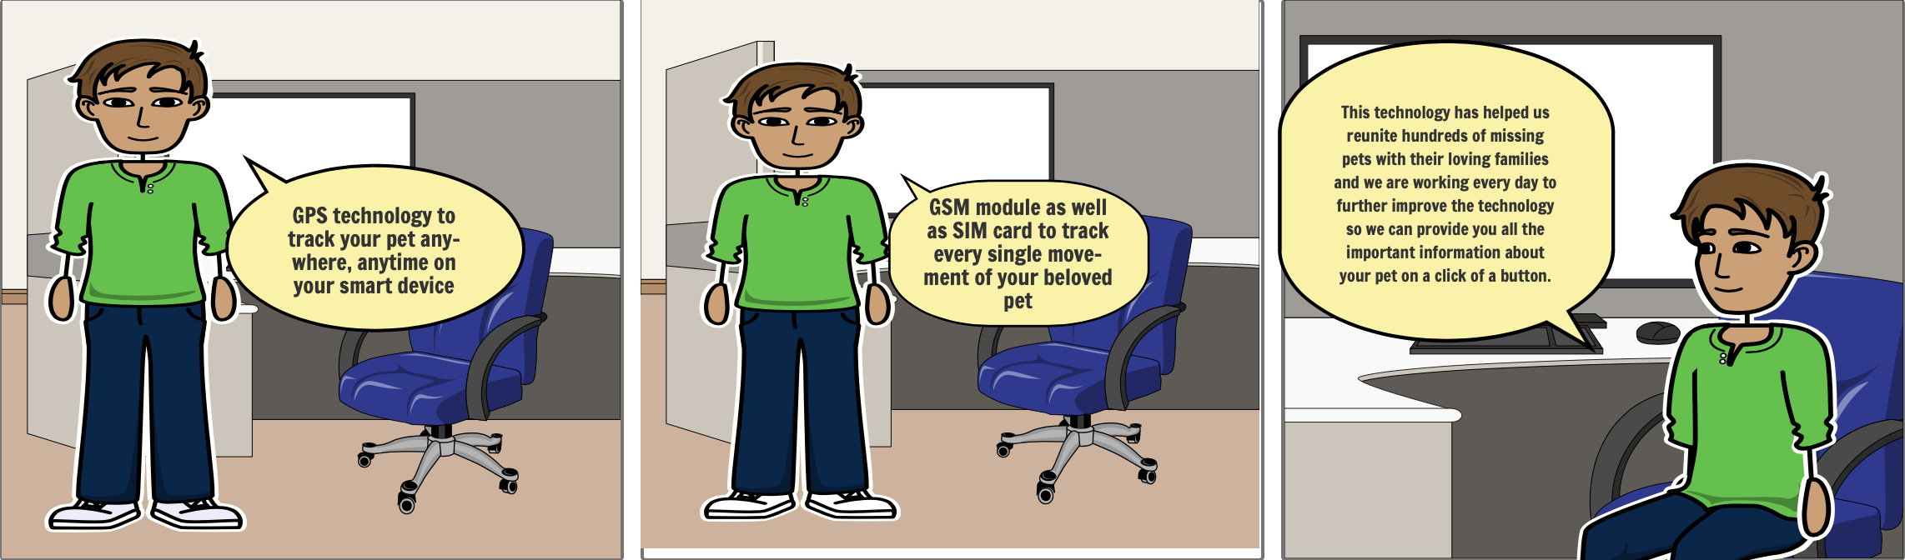

Script:

At pet-finders we understand the bond that you have with your pet and its natural to feel fear of losing a beloved family pet.

Our GPS tracking system is capable of tracking the exact location of your pet in real time. Our GPS tracker can easily be attached to the collar of your pet and it can generate real time data which can be viewed anytime by simply logging into the app on your phone or any other smart device. We use state of the art cutting edge technology and GSM module as well as SIM card to track every single movement of your beloved pet. The GPS system can also detect if your pets leave the set safe zone and can send a notification straight to your phone.

This technology has helped us reunite hundreds of missing pets with their loving families and we are working every day to further improve the technology so we can provide you all the important information about your pet on a click of a button.